The Efficacy of fractional CO2 laser in management of surgical wound scars

A Dissertation
submitted to the Institute of Laser for Postgraduate Studies
University of Baghdad
In partial Fulfillment of the requirements for the degree of High Diploma of Laser in Medicine / plastic surgery
By
Abbas Mohamed Sahun

2012 A. B. 1434 .H

بسم الله الرحمن الرحيم

( لقد خلقنا الانسان في أحسن تقويم )

صدق الله العلي العظيم

سورة التين الآية (4)
Examination Committee Certification
We certify that we have read this dissertation(the efficacy of fractional co2 laser in management of surgical wound scars), and as examining committee we examined the student in its content and in our opinion it is adequate with the standards as a thesis for the degree of Diploma in Laser application in Medicine.

Signature : Signature :
Name : Dr.Lutfi Ghulam Awazli Name : Ahmed Abdul Razzaq Abbood
F.I.C.M.S , HD.L.M M.B.Ch.B F.I.C.M.S
Scientific Title : Instructor Scientific Title : Lecturer
Address : Institute of laser for Address : AL-Nahrain college of medicine postgraduate studies ( plastic surgeon )

Date : / /2012 Date : / /2012
Date : / / 2012 Date : / /2012

Approved by Deanship of institute of laser for postgraduate studies , University of Baghdad
Signature :
Name : Ali Shukur Mahmood
Scientific Title : Assistant Professor .
Address : Acting Dean of the institute of laser for postgraduate
Studies University of Baghdad
Date : / / 2012

Dedication

To my mother

Abbas

ACKNOWLEDGEMENT
-----------------------------

I would like to express my sincere gratitude to the staff of Institute of laser for postgraduate studies / University of Baghdad for their grate help in completion of this study specially Assistant professor Dr. Hussain A Jawad who taught me what is light & how to deal with medical lasers , Dr. Ali Shukur Mahmood who taught me how to deal with laser in a safe manner, & Dr Zainab for learning me the principles of laser work.

This work would not have been possible without the help , suggestion and guidance of Dr. Abdul Khaliq S. Elqurishy.

I would like to extend my sincere thanks to the staff at – Al-Wasti teaching Hospital especially Dr. Naseer Al-Sudani .

I

Abstract
Object:
To assess the safety and efficacy of ablative fractional co2 laser treatments for surgical scarring .

Design :
In this study , each scar received 3 treatments and 3 months follow up.

Patients :-
Seventeen patient ( 12 women, and 5 men ) with various skin types , I to IV , aged 3 to 48 years , presents with 20 scars between June and October 2012 , in face , abdomen , breast , thighs , legs and hands completed all 3 treatments by fractional Co2 laser and 3 months follow up.

Main outcome measures :-
Ery thema ,itching , pain ,tenderness , crusting, edema and petechiae where evaluated on each visit and patient satisfaction.

II

Results :-
The adverse effects of treatment were mild to moderate , no scarring or delayed onset hypopigmentations was observed, patients have demonstrated improvements in skin texture and reduction of pain and discomfort and improvement of tenderness and hardness of the scar which become more soft and mature .

Conclusion :-
The fractional co2 laser treatment represent safe , effective treatment modality for improving scar quality , texture, maturation and appearance.
The use of a co2 laser enables the creation of qualitative improve cornets and minimizes patient down time and the risk of serious adverse effects , reported by patients and investigators in this study.

III

LIST OF ABBREVIATION

CO2 : Carbon dioxide
meter nm : Nanometer = ${1×10}^{-9}$
µm : micrometer = 1× ${10}^{-6}$ meter
Nd : YAG : Neodymium yttrium Aluminum Garnet
› : more than
‹ : less than
Er : YAG : Erbium Yttrium Aluminum Garnet
W : Unit of power
Cw : Continuous wave
Hz : Hertz ( the unit of frequency )
Sec : Second ( unit of time )
AFR : ablative fractional resurfacing
MTZ : microthermal zones
FP : fractional photothermolysis

IV
LIST OF CONTENT
Acknowledgement ………………………………………………………………………… I
Abstract ………………………………………………………………………………………. II, III
List of abbreviation ……………………………………………………………………….IV
List of content …………………………………………………………………………. V, VI,VII
List of tables ………………………………………………………………………………… VIII
List of figures ………………………………………………………………………………. IX

Chapter one : Introduction and basic concepts
1.1 Introduction ……………………………………………………………………………. 1
1.1.1 Aim of the study ………………………………………………………………… 3
1.1.2 Anatomy & Histology of skin …………………….. 4
1.1.3 Epidermis ………………………………………………………………….. 4
1.1.4 basement membrane …………………………….4
1.1.5 dermis …………………………………….4
1.2 THE TREATMENT OF THE SCARS: ………………………………………………… 5
1.2.1 IMMEDIATE POST-OPERATIVE MANAGEMENT OF A SCAR …..6
1.2.2 Conventional treatment ……………………….. 9

V

1.2.6 dermabrasion………………………………………………………………….10
1.3 Laser basics ……………………………………………… ………….………………….. 12
1.3.1 Laser delivery ………………………………………………….……………………. 12
1.3 Laser tissue interaction ……………………………………..……………………. 14
1.6 uses of laser in plastic surgery ………………………………………….…… 19
1.7 Laser safety …………………………………………………………………………….. 28

Chapter two : Patients Materials and Methods
2.1 Introduction ……………………………………….…………………………………. 33
2.2 materials ……………………………………………………………………………………. 35
2.3 Patient selection ……………………………..…………………………………….…. 39
2.3.1 Pre operative consultation ………………..………………………………….. 39
2.4 procedure & method ……………………………………………….……………. 40
2.4.1 post treatment care & follow up ………………………………………….41

VI

Chapter three : Result and Discussion
3.1 Results ……………………………………………………………………………………… 42
3.2 discussion …………………………………………………………………………………55
3.3 conclusion ………………………………………………………………………58
3.4 recommendation & future work …………………………………….. 59

References………………………………………………..

VII

LIST OF TABLES

Table 1.1 Thermal effect of laser radiation …………..…………….……..16
Table 1.2 Some medical lasers and their wavelength………………..…. 20
Table 1.3 The most commonly used laser for treatment of vascular lesion...25
Table 1.4 Lasers with plastic surgery applications…………………..……26
Table 1.5 Clinical conditions treated by different types of laser.…..27
Table 1.6 : Laser hazards……………………………………………….……………28
Table 2.1 No. patients distribution according to sex group…………33
Table (2-2) No. patients distribution in relation to age group…………33
patients in relation to the site of surgical scar….34 No. Table (2-3)
Table (2.5) Co2 laser specifications…………………………………………..36

VIII

LIST OF FIGURES

Fig 1.1 : section of human skin ……………………………………………….……… 3
Fig 1.2 laser tissue interaction………………………………………………………….14
Fig 1.3.( a & b ) Wavelength dependent and Wavelength independent interaction mechanism…………………………………………………….…………….. 15
Fig 2.1 CO2 laser system………………………………………………………………... 35
Fig 2.2 Co2 articulated arm …………………………………………..………..……… 37
Fig 2.3 Materials used in study ………………………………..…………..………… 38
Fig ( 3.1 ) to ( 3.11 ) patients photos ……………………………pp:- 44 - 54

IX

CHAPTER ONE

Introduction and Basic Concepts

1.1 introduction
Surgeons in general ,and especially plastic surgeons, are highly concerned not only with how to obtain a fast surgical wound closure , but to have a flat minimal scarring with no suture marks on its sides or a prolonged wound inflammation process (Grabb & Smith) (1).

Carbon dioxide (CO₂) lasers have been successfully used for many years to treat surgical, atrophic, and acne scars. High-energy short pulses from the 10 600-nm CO₂ laser rapidly vaporize water, intracellularly and extracellularly, which creates precise levels of tissue ablation and minimizes extraneous dermal injury and scarring. Resurfacing with the CO₂ laser ablates and smoothes the skin surface to precise tissue depths, and the deeper thermal coagulation of the dermis drives robust remodeling and neocollagenesis, which correspond to clinical improvement in atrophic scars.(2).
For decades many surgical procedures have been done using traditional instruments but can now be performed with lasers that offer significant advantages to the patient : such as less bleeding or no bleeding at all ("bloodless surgery ") , no scarring , much greater speed of treatment , much less pain of treatment so that little if any anesthesia required less postoperative swelling , and faster healing and recovery .( 3 )
The advent of fractional photothermolysis (FP) revolutionized the field of laser surgery by delivering light energy in a unique beam pattern light to create columns of tissue coagulation in a pixilated pattern (also known as microthermal zones [MTZs]) just below the skin surface. These MTZs are separated by healthy, untreated tissue and protected by an intact overlying epidermis. Density and depths of MTZs can be modified according to the desired clinical result. The presence of an intact overlying epidermis and healthy tissue surrounding each MTZ results in rapid healing and significantly shortened recovery timeThe most commonly observed posttreatment adverse effects of FP are transient and mild and include erythema, edema, dryness, pruritus, and bronzing.(4).
1
1.1.1 Aim of the study
To assess the safety and efficacy of fractional CO2 laser in surgical scarring management.

2
1.1.2 Anatomy And Histology of Skin
The Skin is a complex organ covering the whole surface of the body and it consists of epidermis , basement membrane , dermis and skin appendage , fig . ( 1.1 ) .(5)
Skin is the largest organ of the body with superficial area between 10000 and 18000 cm2 in the average adult , accounting for approximately 15% of the total body weight . ( 6 )

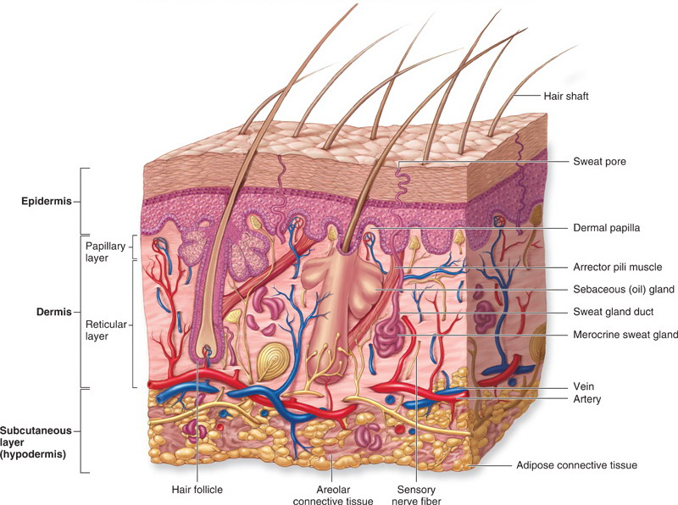

Fig ( 1.1 ) : Section of human skin

3
1.1.3 Epidermis

The most superfacial layer is made up of stratified squameous separated from dermis by basement memberance (7) .
Epidermis contains stratified keratinized epithelium , which can be divided into two zones superfacial horny zone and deep generative zone.

1.1.4 The Basement Membrane .
The basement membrane is a thin connective tissue layer forming the dermoepidermal junction , and it appears as an irregular wavy sharp line . These waves are due to rete pegs , which are inward projections of the epidermis into the dermis at the dermoepidermal junction (1) .

1.1.5 Dermis
Dermis is the essential skin , because epidermis relays on it for nutrition and support . The dermis contains collagen and elastic fibers , cells ( fibrolasts , macrophages , adipose cells , mast cells and lymphocytes ) , blood and lymphatic vessels , nerves and skin appendages . All these contents are embedded in the ground substance , which consist of interstitial fluid ( from blood plasma ) and mucopolysacchrides . The fibroblasts mucopolysacchrides , yellow elastic fibers and white collage fibers . Collage fibers give the bulk and strength of the skin(9) .

4
1.2 THE TREATMENT OF THE SCARS:
Scar evolution leads to three possible abnormalities: scar contractures, hypertrophic scars and keloids. As the quality of a scar is however unpredictable, preventive measures, including the use of ointments and continuous pressure, should always be taken. The treatment of the three main abnormalities is described. No method is perfect and the aim in the treatment of scars must therefore be the prevention of abnormalities . According to its pathology, scar evolution leads to the formation of three different types of abnormality:
- scar contractures
- hypertrophic scars
- keloids
The evolution of the scar depends on various factors, of which some can be altered by therapeutic measures. Others can influence the quality of the scar in a negative way, such as the site of the scar, its healing process, the age, sex and race of the patient, etc.
Nevertheless, the quality of a scar is unpredictable, especially for the first 10-15 days after its appearance. For this reason preventive measures should be undertaken in time to avoid the manifestation of an abnormal .Many observations reveal that from the preventive point of view the combination of this treatment with continuous pressure has encouraging results, especially in extended burn scars.( 10 )
Pressure does not allow the formation of interstitial oedema and restricts the development of new capillaries, For this purpose silicone sheet garments have been invented. They should be applied two weeks after grafting or when spontaneous healing has occur.
5
1.2.1 IMMEDIATE POST-OPERATIVE MANAGEMENT OF A SCAR :
Application of fatty and/or cortisone containing ointment and creams
Reduction of skin tension
Application of continuous compression
Splinting
Preventive measures for scar formation, especially after skin grafting, include the use of splints, particularly in the neck, the upper extremities and hands. They lead, through immobilization, to a softening of the scar. Immobilization in an extreme extension position, as in burns of the neck, leads to diminished contracture.( 10 )

Scar contractures
The treatment of choice for scar contracture is scar revision, combined with another surgical procedure, according to the localization, extent and shape of the scar. For example, Z-plasty can redirect the scar and reduce skin tension. If on the other hand the scar contracture leads to a restriction of the full range of motion, skin grafting or the use of a flap is indicated to cover the tissue defect.( 10 )

6

Hypertrophic scars
It is clinically very difficult to differentiate them from keloids arising from sugical wounds, although they are different pathological entities.
Hypertrophic scars always develop when the primary excision is delayed more than 10 days post-bum. Due to aseptic inflammation, it is not advisable to operate before the first 8 months, unless the scar causes functional disorders. Mean while, various conservative measures can be applied, depending on the scar extent.
Localized scars of small extent are usually treated with steroid injections. The use of an air-jet apparatus ("dermo-iet") is more efficient than the injection with an ordinary needle. With such a needle it is more or less impossible to inject the medicine intralesionally, because of the fibers density. The jet-apparatus has the property of having the appropriate pressure, and the moment of "firing", to insert the medication intralesionally. It seems that the main advantage of the dermo-jet lies in the pressure, which causes a destruction of the irregularly woven fibers. It seems that steroids are also necessary, although it causes a destruction of the fibers. The response to the treatment should be evaluated after the second session, when the hypertrophic scar become soft and itching disappears. The treatment continues in sessions till the scar becomes thinner and softer. The color change is the last of the symptoms to be restored and is observed some months after the treatment is finished.
The surgical treatment varies depending on the extent and the site of the hypertrophic scar. Small scars can be revised and removed, the defect being covered by local or distant flaps. In extensive scars tension should be released primarily, because the scar will not soften and more importantly constant irritation may lead to the formation of precancerous lesions.

7
Small and multiple hypertrophic scars should be treated by dermabrasion. Avoid applying this method during the late spring and summer time with people of dark colored skin, since sun irradiation can result in deeper coloured areas of the skin. In our experience the results are not very satisfactory when dermabrasion is applied to people of darker skin, since it results in a whitish skin area.( 10.11 )
Keloids
Irradiation should not be considered the therapy of choice in benign lesions and in particular in keloids, because of its serious side effects. The combination of excision and post-operative irradiation seems to have good aesthetic results without being of any harm to the patient.
The application of continuous compression as well as of steroids is unfortunatelly not efficient for the treatment of keloids. The use of the Co2-laser to excise the keloid combined with local compression has been recently applied but the results are not encouraging.
The removal of the keloid and coverage of the defect with skin grafts or flaps, combined with continuous compression, seem to be the method which brings the most satisfactory results, and the fewest recurrences.
In conclusion, the treatment of scars cannot be generalized and should always be individualized for each person. It should be stressed that efforts to treat bums must always include the consideration of facing a future disfiguring or disabling scar.It is evident that none of the above methods gives perfect results. For this reason the main aim in the treatment of burn scars is to limit their development by performing an early excision of the primary bum wound. ( 11)
8
1.2.2 Conventional treatment
1.2.3 Drugs :
1- contractubex gel
2- silicon containing gel
3- Bepanthin cream and gel
4- Steroid
5- Silicon sheets
6- Soft tissue filler(1)
1.2.4 Surgical excision :
1.2.5 Derma planning :

9
1.2.6 Dermabrasion :

Dermabrasion involves mechanically resurfacing the skin with an abrasive tip driven by a high –speed rotary hand engine . Either a wire brush or a diamond fraise may be used as the abrading tip to create an open wound that heals by secondary intention .It is technique dependent and the can be precisely controlled . The epidermis is entirely obliterated and there is partial removal of the dermis , which undergoes incomplete regeneration .(1)
1.2.7 Chemical peel :-
Superficial peeling agents such as Jessner solution, Unna paste , salicylic acid , and the alpha-hydroxy acids penetrate to the epidermal-dermal junction . Medium –depth peels penetrate deep to the epidermal-dermal junction and include trichloroacetic acid ( 35%).( 1 )

10
1.2.8 Laser therapy :-
Lasers are one of the most significant technological developments of the twentieth century . lasers are machines that produce a pure and intense form of light that occurs naturally nowhere in the universe . The special properties of lasers have been used to great advantage in medicine and surgery . Many modern surgical procedures would be impossible without laser instrumentation . Surgical lasers produce specific effects that enable precise targeting of abnormal or unwanted tissue while sparing the " good " tissue(9).

11
1.3 Laser Basics
Introduction 1.3.1

The term laser is an acronym for light amplification by stimulated emission of radiation . In 1917 , Einstein introduced the concept of stimulated light emission . The first laser was developed by Maiman in 1959 using a ruby crystal to produce red light with 694 nm wavelengths . In 1963 , Dr.Leon Goldman pioneered the use of laser for cutaneous application by promoting ruby laser treatment for a variety of cutaneous pathology .The development of argon laser , Nd :YAG laser and carbon dioxide ( CO2 ) laser soon followed and served as the focus of cutaneous laser research during the next two decades . Dr. Parrish revolutionized cutaneous laser surgery in 1980s with the introduction of the theory of selective photothermolysis . (12 )

1.3.2 Laser delivery
Transmission of laser cavity to the tissue is provided by one of three devised articulated arms optical fibers or micromanipulators
Articulated arms direct laser energy from the laser cavity to the desired location through a series of hollow rigid tubes with reflective of the laser wavelength being transmitted so that coherence and power are maintained allowing the fine focusing of the exiting beam .

12
Several limitation remain in articulated arm systems despite recent advances to improve their mobility articulated arms are somewhat cumbersome to use in a clinical setting .the mirrors are easily misaligned when either the laser device or the articulated arm is disturbed .despite the aforementioned limitation carbon dioxide or Er. YAG lasers almost exclusively utilize articulated arms because their infrared wavelength are not transmissible along the currently available optical fibers . Both articulated arms and optical fibers can be coupled through a microscope with a micromanipulator which provides a controlled means of moving the laser beam across the surface of human skin .the micromanipulator can also be coupled with a computer for completely perprogrammed and precise skin irradiation .( 13 )

1.3.4 Laser Parameters :
The parameters that determine the type of laser tissue interaction are :
1- Wavelength : expressed in meter unit ( m ) which determines the penetration depth which is affected by scattering and absorption . Penetration depth is difficult to be precise because of the optical properties between individual varies such as condition of skin , age , hydration of skin , blood and fat content
2- Power Density ( PD) (Irradiance) :- Out put power are expressed in watts ( W)
Power = energy ( J ) / time ( s )
PD is one of the most important parameter ; a surgeon must comprehend and apply when using the laser . PD is the number of watts per area is usually expressed in watts per square centimeter .
The area defined as the area of the working spot generated at the laser – tissue interaction . Therefore power density is equal
PD ( W / cm 2 ) = power ( W ) / area ( cm2)
13
3- Energy Density :- Energy are expressed in Joules ( J )
Energy ( J ) = power ( W ) = * time ( s )
Energy density is the total amount of energy ( J ) directed to tissue during treatment
4- Pulsed Repetition Rate ( PRR ) :- PRR are expressed in Hertz ( Hz ).( 14.15)

1.3.5 Laser tissue interaction mechanism:

The interaction of laser light with a biological tissue depends mainly on the optical properties of the tissue as well as properties of the laser light.
When laser light is incident on a tissue, a part of it is reflected at the surface of the tissue; the remaining part of the laser beam penetrates into the tissue and propagates. While propagation, a part of it is absorbed and a part is scattered by the tissue. For a tissue of finite thickness, some part of the radiation is transmitted. These physical processes are schematically shown in fig (1.2 ).

Incident light
Scattering

Absorption

reflection

Transmitted
Figure (1.2 ) Reflection , scattering , absorption & transmission of laser light when it strikes a tissue
14
1(a)-Wavelength dependent interaction mechanism

Photodynamic therapy

Biostimulation
Photochemical
Interaction

Photoablation
Coagulation

Vaporization
Photothermal
Interaction
carbonization
Melting

Photoablation

2(b)-Wavelength independent interaction mechanism
Ultra short

Photomechanical disruption

Plasma induced

Fig ( 1.3a&b) Wavelength dependent and wavelength independent interaction mechanisms
15
1.3.6 Photo thermal interaction:

In this interaction , absorption of photons energy within the rotational and vibration levels leads to increase the kinetic energy and collision between the atoms and molecules, so increase in local temperature is the significant parameter change. Heat generation is determined b y laser parameters and optical tissue properties, primarily, irradiance , exposure time and the absorption coefficient. According to the tissue temperature achieved, different effects like coagulation, vaporization, carbonization and melting may be distinguished.( 16 )

Table(1.1 )Thermal effect of laser radiation .

Biological effect | Temperature
Normal | 37° c
Hyperthermia | 45 °c
Reduction in enzyme activity, cell immobility | 50° c
Denaturation of proteins and collagen, coagulation | 60° c
Permeabilization of membranes | 80° c
Vaporization, thermal decomposition | 100° c
Carbonization | >150 °c
Melting | >300°c

16
In photo thermal interaction, Photo ablation is due to thermal stress as a result of absorption of high intensity laser light photons. In which the photon energy is not high enough for the molecules to reach a repulsive state. The molecule is promoted only to a vibration state within the ground level or to a rather low electronic state including any of its vibration states. ( 16 )

Photo ablation:
In photochemical interaction , photo ablation is due to bond breaking, volume stress as a result of absorption of high intensity laser light photons.

2-Wavelength independent interaction mechanisms:
a-Photo ablation:
The energetic photons of the laser light decompose the molecules by breaking the bonds at the impart excess energy for ejection. In this interaction, photo ablation is due to volume stress as a result of bond breaking.
In photo thermal interaction, photo ablation is due to thermal stress as a result of absorption of high intensity laser light photons.(17)

17
b-Plasma Induced Ablation:

Interaction of ultra short laser pulses at high intensities causes plasma break down at the tissue that gain energy will be freed and produce a collection of free electrons and ions called plasma. Rapid expansion of plasma creates acoustic and shock waves that combined with latent tissue stress incise the target tissue, producing photo disruption.(13)

18
1.6 Uses of laser in plastic surgery
Laser in Plastic Surgery:
Since the advent of the first laser, scientists and physicians have been working together to develop medical applications. Each laser has distinct uses depending on the laser wavelength, power output and target chromophore(16 ) (table 1.7).
Laser therapy is not without complications and the safety of both patient and operator must remain paramount. Some of the potential advantages of laser in surgery include: (18,19)
- -No-touch technique
- -Reduced blood loss
- -Limited fibrosis and stenosis
- -Fiberoptic delivery allowing access to difficult sites.
- -Potential reduction in spread of metastasis
- -Fewer instruments in the field (convenience)
- -Reduced postoperative pain.
- -Sterilization of the impact site
- -No interference with monitoring equipment (compared with some electrosurgical procedures)
- -Dry surgical field (heamostasis)
- -Reduced edema (when tissue manipulation is reduced)

19
12 -Precision (high degree of control over lateral damage – the
quintessential advantage of laser over electro surgery in many
applications)
13-Unique Capabilities - some systems (dermatology, ophthalmology,
some others) provide a means of treatment either unavailable from
other technologies, or of significantly better utility.
Lasers are versatile instruments capable of treating an ever increasing array of skin conditions. Various vascular, pigmented, epidermal and dermal lesions can be selectively destroyed by using lasers that correspond to the absorption characteristics of the intended target without damaging normal healthy surrounding skin structure such as epidermal pigment and dermal collagen (16).

Table 1.2 : Some Medical lasers and their wavelengths .
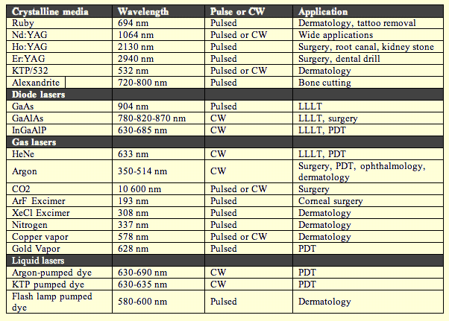
20
Laser in medical uses
Laser skin resurfacing
It is used to :
Treat wrinkles of aging skin of the face
Treat surgical scars . acne scare and other scars
Laser used :
- Carbon dioxide laser
Char – free CO2 laser ( 10600 mm) enable precise surface tissue ablation allowing skin resurfacing of wrinkles and removal of surface pigmentary abnormalities about 20-25 um of tissue is removed with each laser pass two different techniques are used .pulsed CO2 lasers and continuous CO2 lasers with scanners .
- Er: YAG laser
In both laser the prices surface tissue ablation allowing skin resurfacing of wrinkles and skin pigmentary abnormalities . so skin surface color is improved by mechanical removing damage skin . collagen shrinkage and collagen remodeling improve skin texture ( 20 ).

21

1- Incision surgery

CO2 laser acts as a cutting tool in the focus mode . Its advantages over traditional cutting tools are decrease bleeding , decrease infection , decrease oedema and decrease pain ; because during cutting laser seals vessel and nerves. It is used for patient with bleeding disorders or patients taking anticoagulant drugs . Also laser used in highly vascularised tissue or infected tissue as treatment of large infected bed sores .

Nd : YAG laser is also used for cutting and coagulation . Its advantages over CO2 laser are better coagulation and delivered through fibro- optics . So it can be used with endoscopic surgery that has been newly started in plastic surgery , as endoscopic augmentation mammoplasty (21) .

2- Malignant skin lesions

- Ablation of the basal cell carcinoma (BCC) by laser it is used in areas where surgical excision affect function or cosmetically no accepted as in the face .
- Surgical excision of the BCC or SCC (squamous cell carcinoma ) by laser as a cutting tool .
- Photodynamic therapy (PDT) it is a local treatment relying on the presence of photosensitizer and oxygen the subsequent irradiations of the photosensitized tissue with non-ionization laser radiation generate tissue damage. (21)

22
The technique is by injecting the photo sensitizer (as HPD2.5-5mg/kg) intravenously or by topical application of the photo sensitizer(as for hair removal ) within few hours of injection it will distributed to all soft tissue except brain after 48-72 hours most of it is cleared from healthy tissue while it remains concentrated in tumor cell (30times the normal tissue ) due to higher affinity the HPD remains inactive until irradiated . usually in day 4-7 by laser (630nm) excitation of HPD will cause type I reaction (free radical ) and type II REACTION (TRANSFER OF EXCITATION energy to oxygen molecules ,causing necrosis of the target tissue
Advantage of PDT are sparing normal skin and resulting in minimal scaring(12,21) .

3- Benign skin lesions

- Rhinophyma syringioma and adenoma can be removed effectively by skin resurfacing using CO2 laser.
Rhinophyma is excessive thickening of nasal skin usually in alcoholicsand skin graft .
- Warts can be ablated by CO2 laser to the basement membrane of the skin . also pulsed dye laser (585nm) to coagulate warts .
- Actinic chelitis can be treated with minimal scarring using Co2 laser with low energy and defocusing (21) .

23

4- Pigmented skin lesions

Melanin absorb from ultraviolet to near infrared portion of the electromagnetic spectrum the highest selectivity is found in red and near infrared portion . since haemoglobin has less absorption in this region . also melanin has relatively higher absorption than hemoglobin in blue – green range .

- Deep dermal pigmented lesions as nevus of ota and blue nevi, required longer wavelength laser for better penetration as Q-switch ruby (694nm, 20-40ns) Q-switch alexandrite (755nm 50-100ns) andQ-switch Nd: YAG (1064nm, 10 ns ).
- Epidermal lesion as lentigo simplex . solar lentiginous and labial melanocytosis maculesrespond to short wavelength as green pulsedye laser (510nm. 300ns ) frequency doubled Nd: YAG (532nm 10ns) andQ-switch ruby (694nm ,20-400 ns ) .(21).

5-Vascular lesions
Laser is used to coagulate blood in the target abnormal veesels and selectively destroy vasecular lesions hemoglobin is used as an endogenous chromophore with high absorption of visible laser and peak in yellow portion (577 nm)(20).

24
The table ( 1.3 ) the most commonly used laser for treatment of vascular lesion
Laser | Wavelength | Type
Argon | 488-574nm | CW
Q-switch Nd:YAG frequency doubled | 532nm | Pulse(20ns)
Nd:YAG frequency doubled | 532nm | Pulse(1-15ms)
Pulsedye laser | 577-600 nm | Pulse (450us)
Copper vapour | 578nm | Pulse
Argon dye | 577-630nm | Pulse

6- Striae distensea
These stretch marks are due to steroid .due to rapid increase in size as pregnancy or due to rapid increase of weight in obesity . stretching cause destruction of elastic fibers in skin and striae distensae formation .
The conventional medical treatments as tretinon are not effective .pulsed dye laser (585 nm ) with a large spot size and low flounce is beneficial (12) .

25
7-Killods and hypertrophic scars
- pulse dye lasers (585nm) decrease vascularity of the lesion and cause rapid atrophy .
- Diode laser (910nm) and Nd: YAG (1064nm) penetrate deeply and cause necrosis the lesion and atrophy .

able ( 1.4 )Lasers With plastic surgery application T
------------------------------------------------------------------------

Target chromophore | Wave length (nm ) | Laser
Melanin , tattoo pigment | 694 | Ruby
Pigment | 1046 | Neodymium : YAG
Oxyhemoglobin , melanin | 532 | KTP
Water | 2940 | Erbium : YAG
Melanin ( oxyhemoglobin ) | 800 | Diode
Melanin , tattoo pigment | 755 | Alexandrite
Oxyhemoglobin | 578 | Cooper vapor
Oxyhemoglobin | 585 | Yellow dye
Oxyhemoglobin | 595 | Yellow dye
Melanin | 510 | Green dye
Oxyhemoglobin , melanin | 488,514 | Argon
Water | 10600 | Carbon dioxide
Breaks chemical bonds | Ultraviolet  variable ( 193 ) | Eximer

26
Table (1.5 )Clinically useful lasers and other phototherapy

Type of laser | Lesions
Yellow dye  KTP  Nd: YAG  Copper vapour  Intense pulsed light | Vascular
Carbon dioxide  Erbium : YAG  Radiofrequency | Skin resurfacing
Intense pulsed light  Diode  Ruby | Benign lesions , pigmented
Carbon dioxide | Benign lesions, cutaneous
Alexandrite  Diode  Neodymium : YAG  Ruby  Intense pulsed light | Hair removal
Ruby  Alexandrite  Neodymium : YAG | Tattoo removal

27

1.7 Laser safety

Laser safety for both the patient and operating room staff, including the surgeon, has become a complex issue due to the wide variety of wavelengths, maximum power levels and delivery methods available in today's medical lasers.
Hazards from the laser include direct and indirect (reflected) beam exposure; fire hazards; smoke produced by vaporization (containing pathogen and chemical toxins); as well as the standard safety measures needed for electrical and electronic equipment .Table 1.9 summarizes laser hazards:(22)
Table 1. 6 : Laser hazards

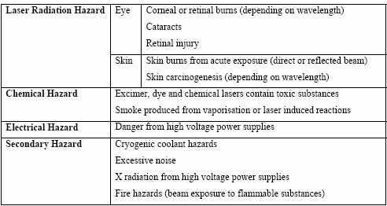

28
Generally speaking, all laser devices and systems are classified into 4 classes. Medical lasers, which are Class IIIB and IV lasers, are available in all wavelengths, ultraviolet to infrared, and by definition operate at high power levels.
They are a possible hazard to eyes and skin and tissue heating may produce a smoke plume. Potential damage to the skin and parts of the eye are well documented and understood. Eye damage falls mainly into two categories: damage to the retina by visible and near infrared wavelengths and to the cornea by far UV and infrared.

In those laser systems, The American National Standards Institute requires the laser key to be stored separately from the laser to prevent unauthorized use. Patients and all personnel present must wear wavelength specific safety goggles. There should be a limited number of entrances to the laser suite, each marked clearly with a laser warning sign. An extra pair of safety goggles should be left outside the door in areas of high traffic, such as an operating room. Treatment around the eyes may require using corneal eye shields. The patient should be further protected with wet drapes or crumpled aluminum foil (to reduce the risk of reflected laser light) .A laser-safe endo tracheal tube should be used when lasing in or around the oral cavity.(23)
The lowest possible fraction of inspired oxygen should be used to decrease the risk of an inhalation or flash burn. Exhaled oxygen can ignite singed nasal or lip hairs when using the CO2, pulsed yellow dye, or hair-removal lasers in the setting of enriched oxygen delivery. Lasers that create significant laser plume, such as the CO2 laser, should be used with a plume evacuator to prevent potential transmission of live virus particles into the airway of treating personnel. When lasing warts, a viral mask is also highly recommended in addition to the plume evacuator, and the potential viral contamination can be reduced by shaving the bulk of the wart prior to laser vaporization of the base. (24)
29

. Lastly use of an expensive laser to treat conditions outside its capabilities,
or exaggeration or falsification of the treatment outcome for momentary gain is unethical and medico legally dangerous. Patients should have a realistic understanding of the expected results and the risk of treatment, as well as other treatment options .(23,24)

30

Hazard evaluation and classification:
Lasers are classified to describe the capability of a laser system to produce injury to personnel.
Class I lasers:
Are low powered devices that are considered safe from all potential hazards . Some examples of class 1 laser use are: laser printers, CD players, CD ROM devices. No individual, regardless of exposure conditions to the eyes or skin, is expected to be injured by a Class I laser. No safety requirements are needed to use Class I laser devices.

Class II lasers:
(Visible lasers: 400 to 700 nm) are low power<< 1mW. Visible light lasers that could possibly cause damage to a person´s eyes. Some examples of Class II laser use are : classroom demonstrations, laser pointers, aiming devices and range finding equipment. If class II laser beams are directly viewed for long periods of time (Le. > 15 minutes) damage to the eyes could result . Avoid looking into a Class II laser beam or pointing a Class II laser beam into another person's eyes. Aviod viewing Class II laser beams with telescopic devices. Realize that the bright light of a Class II laser beam into your eyes will cause a normal reaction to look away or close your eyes. This response is expected to protect you from Class II laser damage to the eyes.(24)

31
Class IIIa lasers:
Are continuous wave, intermediate power (1-5 mW) devices. Some examples of Class IIIa laser uses are the same as Class II lasers with the most popular uses being laser pointers and laser scanners. Direct viewing of the Class IIIa laser beam could be hazardous to the eyes. Do not view the Class IIIa laser beam directly. Do not point a Class IIIa laser beam into another persons eyes. Do not view a Class IIIa laser beam with telescopic devices; this amplifies the problems.(24)
Class IIIb lasers:
Are intermediate power (cw. 5-500 mW or pulsed 10 J/cm2) devices. Some examples of Class IIIb laser uses are CW and pulsed dye lasers used in spectroscopy and entertainment light shows. Direct viewing of the Class IIIb laser beam is hazardous to the eye and diffuse reflections of the beam can also be hazardous to the eye. Do not view the Class IIIb laser beam directly. Do not view a Class IIIb laser beam with telescopic devices; this amplifies the problem.
Class IV lasers:
Are high power (cw> 500 mW or pulsed > 10J /cm2) devices. Examples of Class IV laser are: Argon ion and Nd : YAG lasers used to pump CW and pulsed dye lasers . The direct beam and diffuse reflections from Class IV lasers are hazardous to the eyes and skin. Class IV laser devices can also be a fire hazard depending on the reaction of the target when struck. Much greater controls are required to ensure the safe operation of this class of laser devices. Whenever occupying a laser controlled area, wear the proper eye protection . Most laser eye injuries occur from reflected beams of class IV laser light, so keep all reflective materials away from the beam. Do not place your hand or any other body part into the class IV laser beam. The pain and smell of burned flesh will let you know if this happens. Realize the dangers involved in the use of Class IV lasers and please use common sense.(23,24).
32

CHAPTER TWO
Patients ,Materials and Methods

Patients ,Materials and Methods
2.1 INTRODUCTION
In this chapter details about the patients, materials and laser apparatus were used in this study , including:, equipments , materials and laser system used.
All procedures have been conducted at the laser center at Al . wasity Hospital in Baghdad- Iraq. Between June and October 2012 .
Seventeen patients with twenty scars completed the three months follow up visit after the final treatment by scanned co2 laser .
No. patients distribution according to sex group. Table (2-1)

Female | Male | Total
12 | 5 | 17

Table (2-2) Patients distribution in relation to age group
No. of patients | Age group
3 | Less than 10 years
10 | 10 – 30 years
4 | 30- 50 years

33

Patients in relation to the site of surgical scar : Table (2-3)

No. of patients | Site
6 | Face
2 | Breast
3 | Abdomen
2 | Hands
4 | Others

34
2.2 Materials :-
2.2.1 laser device used :
Co2 laser system,( 10600 nm ) emits laser in variable modes (continuous , single pulsed , Repetitive pulse ,scanned , and ultra pulse ).
Figure (2.1) shows photograph of co2 laser device .
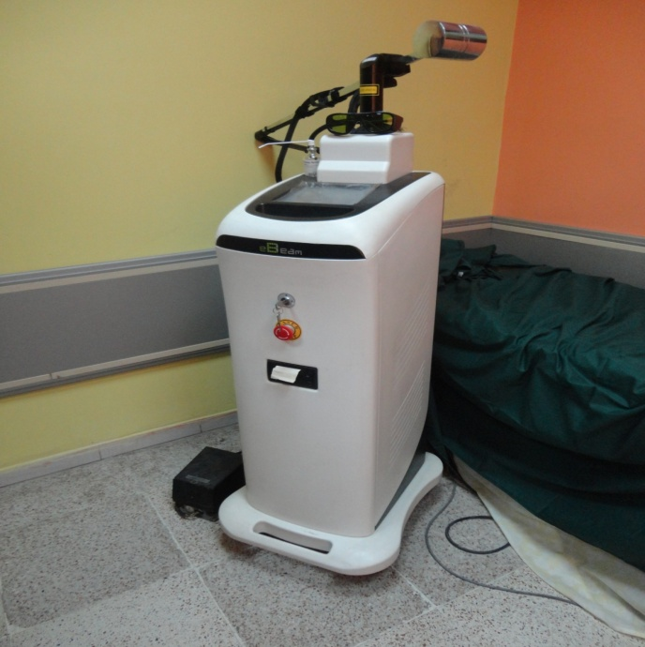

Fig (2.1) Co2 laser system

35
The technical specifications of the chosen co2 laser are shown in the table (2.1) :

Table (2-1)

36

The output of this device was delivered to the target site via an articulated arm ……fig (2.2)

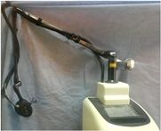

Fig.(2.2) Co2 articulated arm

37

2.2.2. Other Equipments and instruments :
_ Surgical gowns
_ Surgical gloves
_ facial masks
_ sterile normal saline 0.9%
_ Xylocaine spray 2%
_ xylocaine injection 1 %
_ eye protection goggle

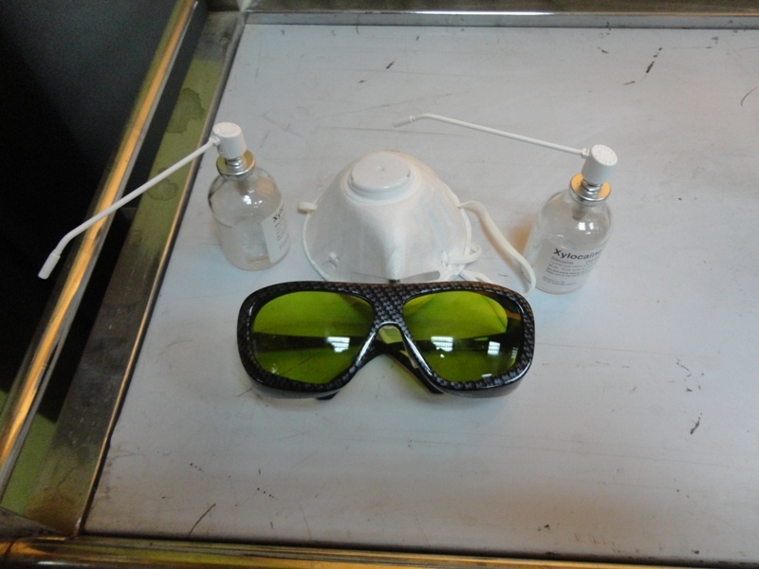
Fig. ( 2.3) shown these material used in this study.

38

2.3. Patients selection:

A thorough history from each patient about past and present medical illnesses especially herpes simplex to those with facial scars, any history of previous medications used for the scar which may important to improve the result of scar, example Hydroquinone 4% cream or use of fibrinolytic agent like contractubex gel (trade name ).
It was imperative to examine the scar properly especially fresh wound scars where the sutures were taken off earlier, the examination include evaluation of any stitch abscess or inflammations and dehiscense which need to be controlled first .

2.3.1 Preoperative consultation :-

Preoperative consultation were done to find out the patient expectations and agreements about the results , to exclude those patients who had unrealistic expectations . After the patients goals had been discussed and reasonable expectation , informed consent was discussed.
Potential complications were then discussed including , pain and discomfort during and after applications of laser therapy , hyperpigmentation , hypopigmentation and redness which may last few days to weeks according to sites and colour of the skin.

39

2.4 . Procedure and methods :-
2.4.1. preparation of surgical wound scars :-
The scars wiped with gauze containing alcohol , 70 %, and then anesthetized with either local xylocaine spray 2 % or subcutaneous lidocaine hydrochloride 1 % injection , using a hypoderm needle 10 to 15 minutes before the procedure.

Prophylactic acyclovir hydrochloride was not administered to patient because no history of herpes simplex infection .
Prior to treatment with co2 laser , moist drapes were placed around the field and the patient s eyes were protected with proper eye shields .
All treatment were performed with co2 laser using scanned mode power ranged formed 5-10 w according to site of lesion .
The hand piece used to deliver the laser energy adjust to the speed at which the operator moves which is around 0.5 cm per second , so each pass delivers the same energy , and usually apply 1 to 3 passes per treatment area.
Post treatment erythema , edema and petechiae and some time pinpoint bleeding are usually has resolved within one week to 10 days after the treatment , darkened crusts on the scar has takeoff also with few days.

40

2.4.2.Post treatment care and follow up:

Soothing agents like calamine cream were applied 2to 3 times per day post treatment and sometimes Bepanthin cream which help the regeneration of epithelium especially when the scars are peeled a thick crust is formed .
The first visit after one week to two weeks.
If erythema , crust, and edema subsided the second session was planned. The photodecument for the changes of the scars was taken.
Massage of the scars was encouraged to help up the remove of the crust and resolve the edema which is usually happened during the first week.

41

CHAPTER THREE

Results & discussion

Results & discussion
Results : : 3.1
seventeen patients with twenty scars completed the three month follow up visit after the final treatment by scanned fractional co2 laser .
Post laser treatment immediate erythema was noted , it usually subsided within 5-7 days . after the second and third treatments erythema subside and it become mild and by the end of the study nearly completely disappeared .
Edema was observed immediately after treatment , which also continue for 1 wk and then resolved with time and massage in all patients , except in one patient with nose tip skin graft after excision of pigmented nevus continue after 3 months of the follow up.
Post procedure petechiae have resolved in all by 5-7 days of the 3 treatments , no remaining petechiae after 6 wks follow up examinations.
In those patients with darkened skin type IV skin , mild to moderate hyperpigmentation was noted after all 3 treatments but it resolved nearly in all patient within duration of the study .

42
Hypopigmentation was noted for a days in those patient with type II ,III skin types which improved without treatment .
Crusting and pinpoint bleeding tend to resolved in first week of treatment except in those with abdomenoplasty scar which remained more than 10 days .
No treatment induced scarring was observed throughout the study peroid .
No bacterial infections or episodes of viral re activation occur.

43
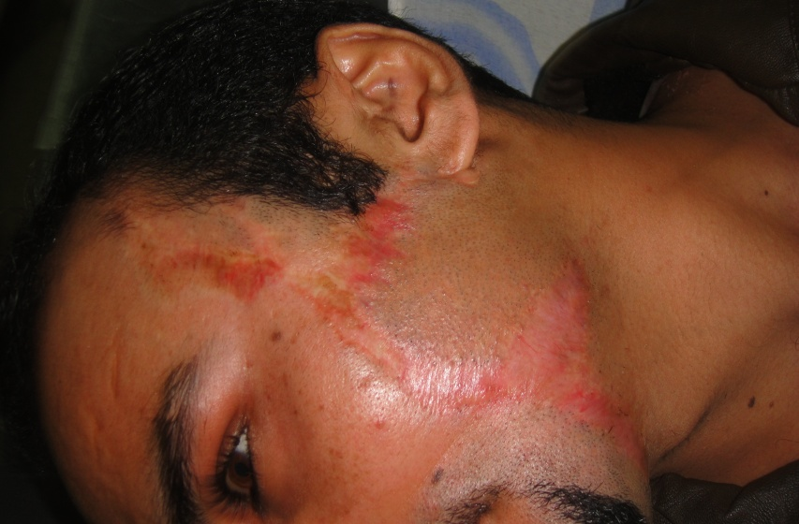

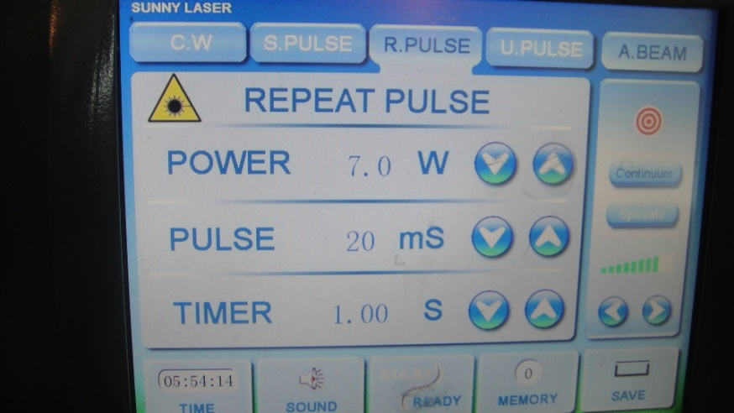
Fig (3-1) – Pre.

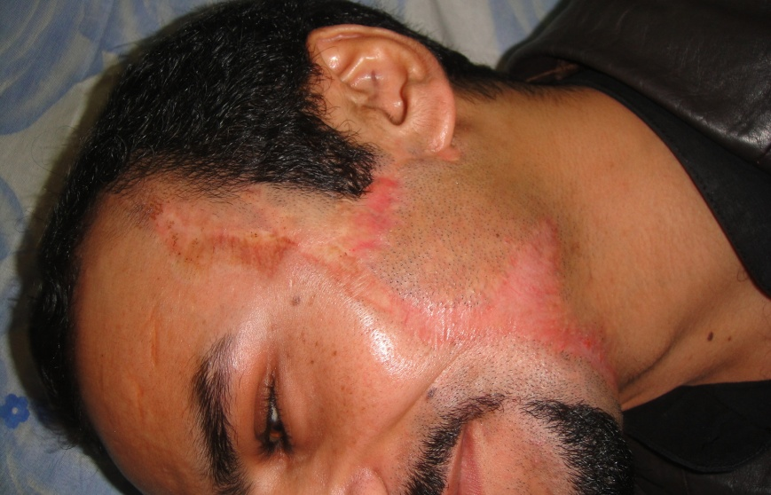

Fig (3-1) – Post three sessions of 5-7w of repeated pulse of Co2 laser

44
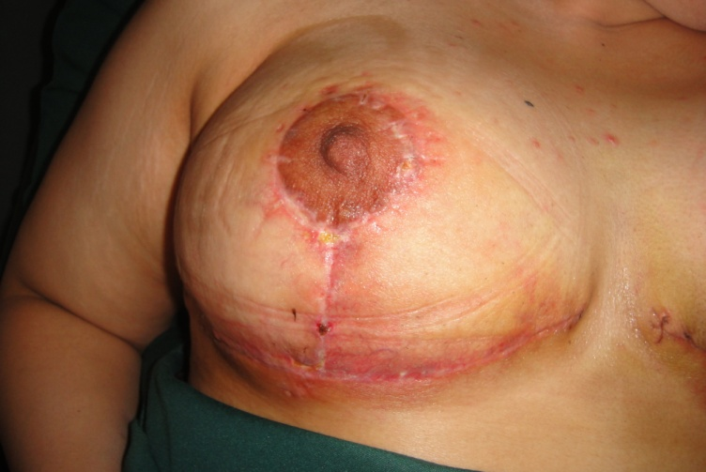

Fig (3-2) – Pre.
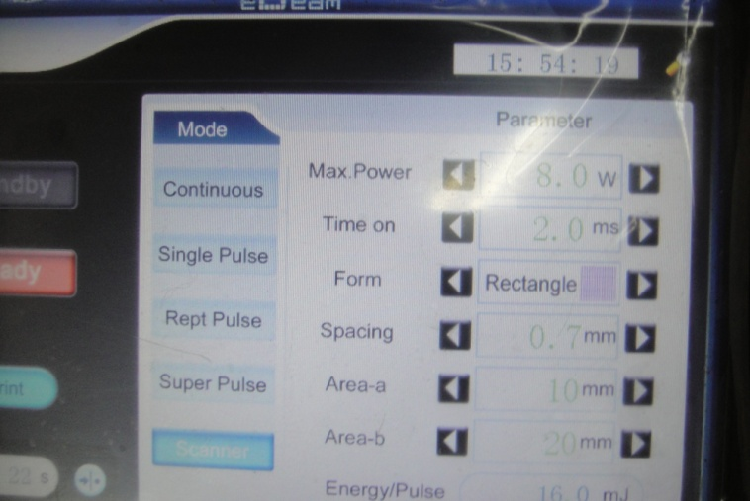

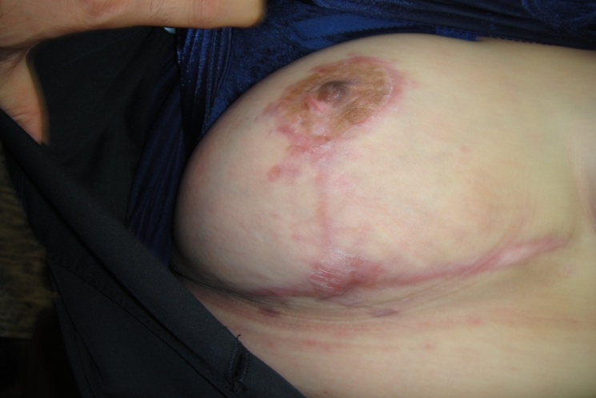

Fig (3-2) – Post four sessions of 8w of repeated pulse of Co2 laser
45

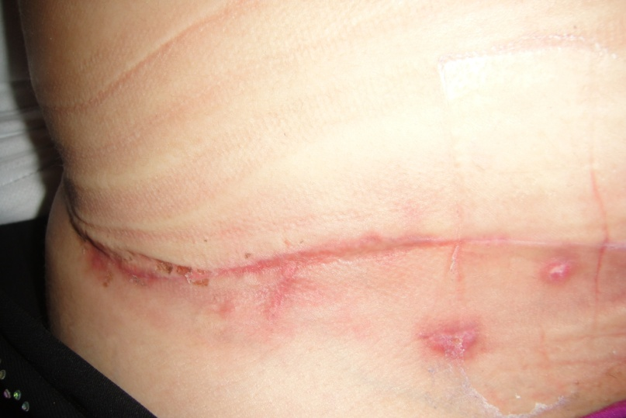

Fig (3-3) – Pre. laser of abdomenoplasty surg .scar
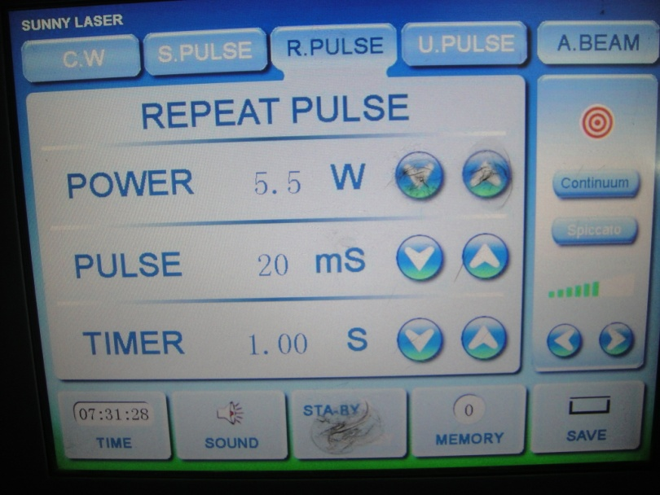

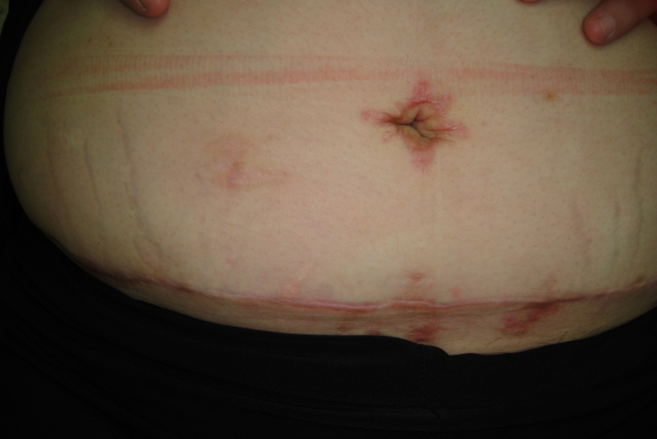

Fig (3-3) – Post three sessions of 5.5w of repeated pulse of Co2 laser.
46
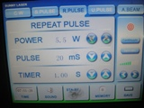
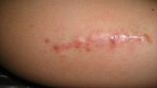
Fig (3-4) – Pre. laser of thigh surg .scar.

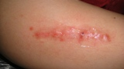

Fig (3-4) – Post three sessions of 5.5w of repeated pulse of Co2 laser..

47
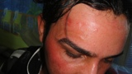
Fig (3-5) –pre laser facial scar.

Fig (3-5) – Post three sessions of 5.5w of repeated pulse of Co2 laser..
48
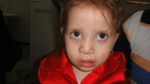
Fig (3-6) –pre laser lip scar .

Fig (3-6) – Post three sessions of 5.5-6w of repeated pulse of Co2 laser..
49
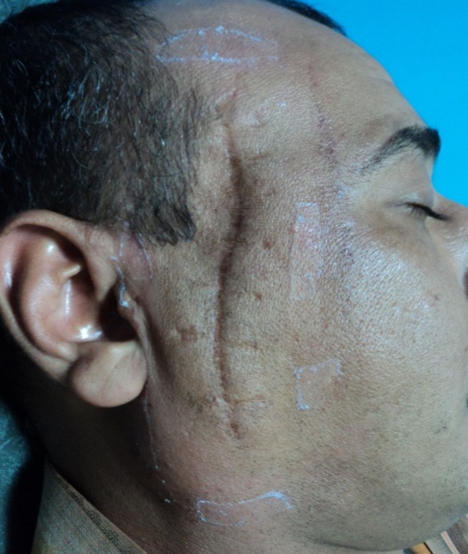
Fig (3-7) –pre laser facial scar.
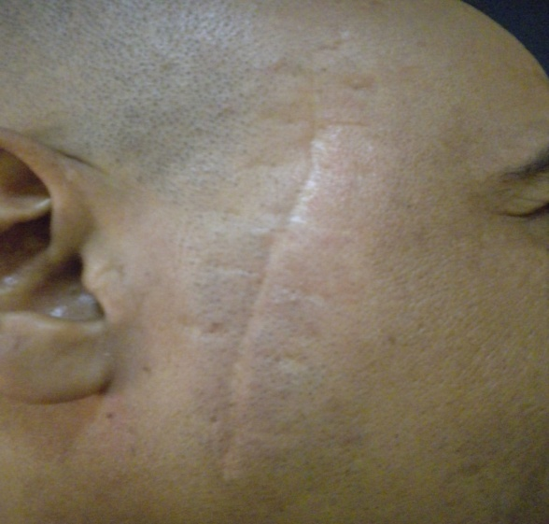
Fig (3-7) – Post five sessions of 5-7w of repeated pulse of Co2 laser..
50
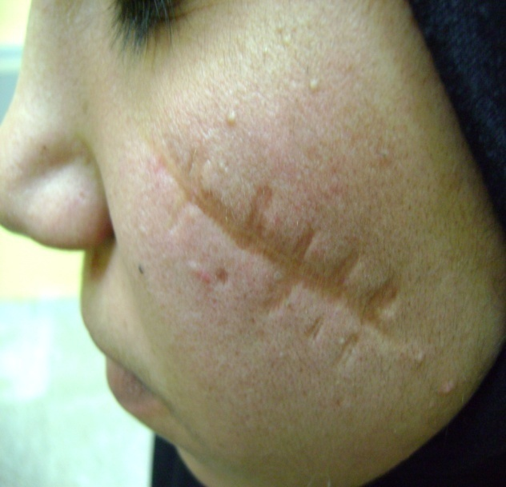
Fig (3-8) –pre laser facial scar .

Fig (3-8) – Post.
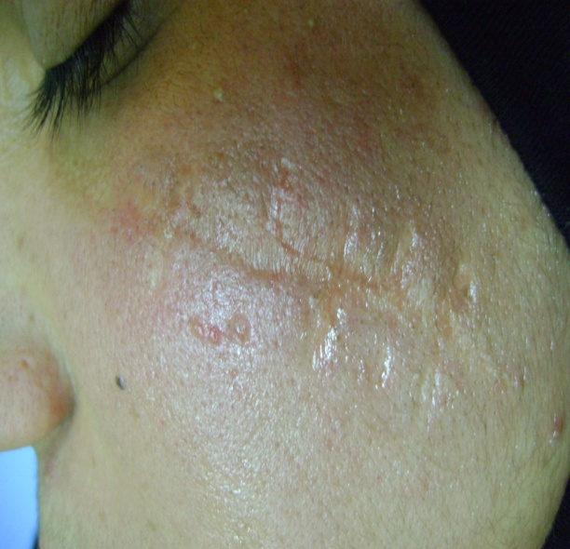

Fig (3-8) – Post five sessions of 8w of repeated pulse of Co2 laser.

51
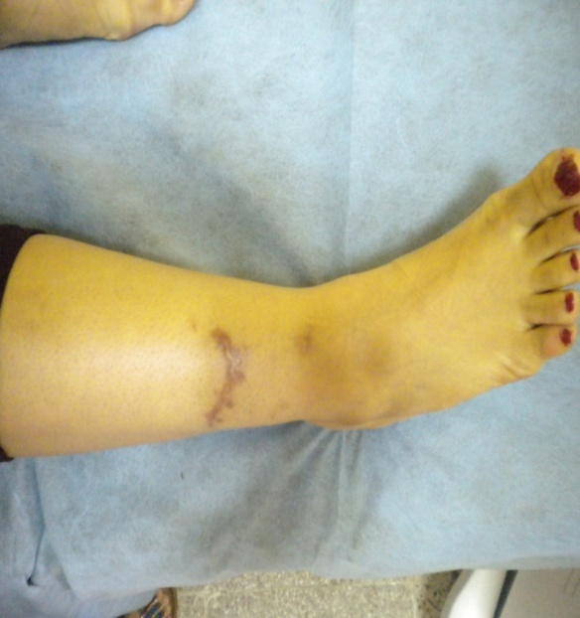

Fig (3-9) –pre laser leg surg. scar

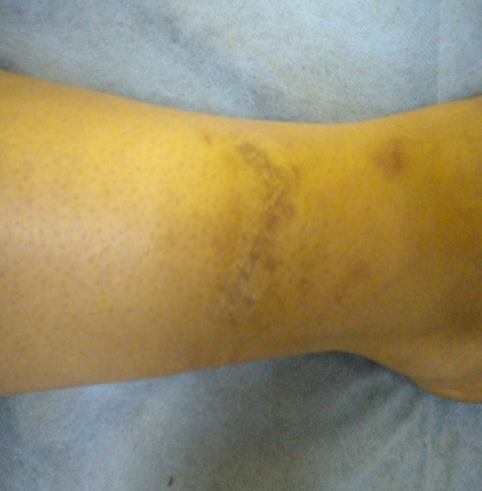
Fig (3-9) – Post four sessions of 8w of repeated pulse of Co2 laser.
52
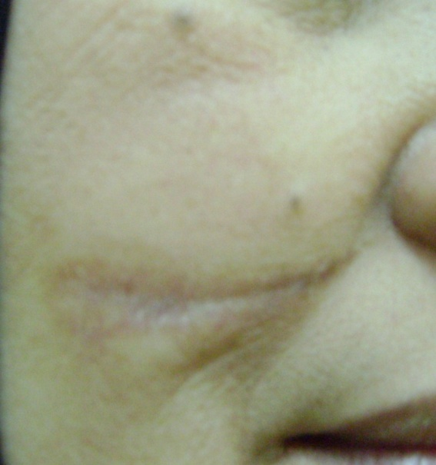
Fig (3-10) –pre laser facial scar.

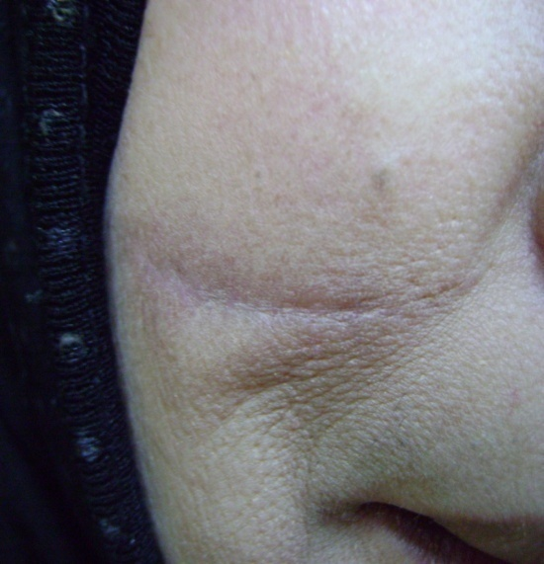
Fig (3-10) –post three sessions of 5.5w of repeated pulse of Co2 laser.

53

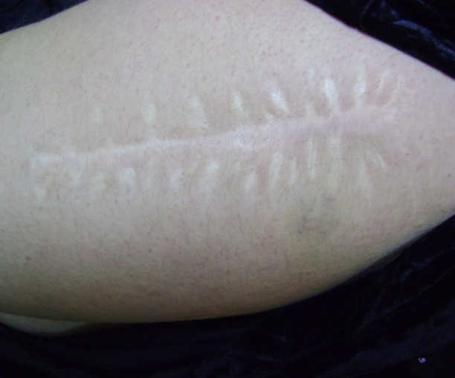
Fig (3-11) –pre laser thigh surg. scar

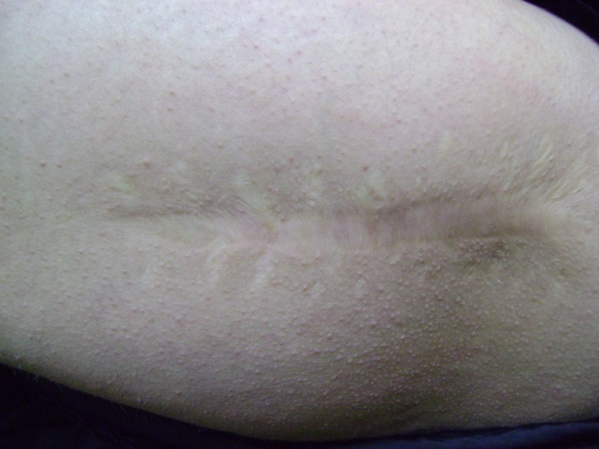

Fig (3-11) –post three sessions of 8w of repeated pulse of Co2 laser.
54
3.2 Discussion:

Wound scarring occurring after surgical procedures or trauma is a common cosmetic problem for patients. Atrophic scars, which present as topographical depressions, result when dermal collagen and connective tissue production during the physiologic wound-healing process inadequately compensate for the tissue loss present after injury. Wound tension, tissue apposition, individual variations in wound healing, and scar contraction are all factors that contribute to the creation of a depressed, atrophic scar. With varying success, numerous ablative, non ablative, and fractional devices have been used to stimulate neocollagenesis and dermal remodeling in an attempt to improve the appearance of atrophic scars and hyper trophy scar .(25)
Although effective in improving scar appearance, CO₂ laser resurfacing generates significant tissue damage and therefore carries higher risks of adverse effects. After facial resurfacing, the average time to reepithelialization is at least 5 to 7 days, and the postprocedure erythema generally lasts 4 to 8 weeks, depending on the depth of ablation and extent of thermal injury This prolonged recovery often prevents patients from resuming normal activities in a timely manner. Other potential transient adverse effects include edema, oozing, milia, crusting, pain, acne flares, and pruritus. More serious adverse effects include bacterial infection, viral reactivation, scarring, and immediate or delayed permanent pigmentary alteration. Delayed-onset hypopigmentation is a well-documented adverse effect of CO₂ laser resurfacing, and this effect detracts from the overall cosmetic outcome and significantly lowers patient satisfaction.The risky adverse effect profile and prolonged recovery period deter many physicians from using CO₂ laser resurfacing for scar revision.(26).

55
With nonablative FP, despite the lack of tissue ablation, scarring can be moderately improved with a series of treatment sessions. combines CO₂ laser ablation with an FP system in a treatment known as ablative fractional resurfacing (AFR). A pixilated pattern of microscopic ablative wounds surrounded by healthy tissue is delivered to the skin,and this combines the enhanced efficacy of tissue ablation with the shorter healing times and improved safety of FP technology. The AFR treatment avoids widespread epidermal coagulation while generating zones of tissue ablation and thermal coagulation much deeper than those seen with traditional ablative resurfacing. Deep zones of ablation and coagulation produce robust dermal remodeling, tissue tightening, neocollagenesis, and, ultimately, clinical improvement in atrophic scarring.(27).
Treatment with AFR was previously demonstrated to safely improve the appearance of atrophic surgical scarring by reducing the depth of individual scars. In this prospective study, we evaluated the efficacy of AFR in the treatment of atrophic surgical and traumatic scars.

. This impressive, uniform improvement across all scar variables is likely related to the ability of AFR to generate deep dermal ablation and coagulation to depths beyond those reached by traditional CO₂ laser resurfacing. Although not statistically significant, facial scars that were routinely treated at higher energy fluences generally responded to a greater degree and had a more uniform response compared with off-face scars. This observation is likely related to the deeper levels of ablation and coagulation obtained with higher energy fluences. At higher fluences, tissue ablation and coagulation extend beyond 1 mm into the skin; this deep thermal effect may produce more robust dermal remodeling and collagen production.( 27 )

56
During the follow-up, no incidents of delayed-onset hypopigmentation, permanent pigmentary alteration, or scarring were observed. Treatments were well tolerated by patients, and adverse effects were generally mild to moderate. Compared with conventional CO₂ laser resurfacing, AFR treatments provided a safer adverse effect profile, a more rapid healing period, and shorter downtimes for patients.
After traditional CO₂ laser resurfacing, delayed-onset hypopigmentation can be seen, however, no incidents of delayed pigmentary alterations were observed. From the date of the first treatment to the final 3-month follow-up, patients were followed up with no evidence of delayed pigmentary alteration. The preservation of healthy untreated skin between zones of thermal ablation likely explains the lack of delayed, permanent pigmentary problems after AFR treatment. Transient mild to moderate postinflammatory hypopigmentation/hyperpigmentation developed in less than half of the AFR-treated scars, but these pigmentary changes all resolved spontaneously by 3 months after the final treatment.
The treatment protocol was based on our prior experience with nonablative resurfacing and AFR treatments for acne scars. As we have observed previously, improvement follows the first treatment, and subsequent treatments lead to incremental improvements in scar appearance. Although treatment intervals varied from 1 to 4 months, patients generally reported that the oozing, crusting, and edema after the second and third treatments tended to be shorter and better tolerated.( 28 )

57

Conclusion : 3.3

The ablation fractional Co2 laser treatment represent safe , effective treatment modality for improving scar quality , texture, maturation and appearance.
The use of fractional a Co2 laser enables the creation of qualitative improvements and minimizes patient follow up time and the risk of serious adverse effects , reported by patients and investigators in this study.

58
Future work : Recommendations & 3.4

Further researches into the most effective treatment for surgical scar , and further study to evaluate the effect of co2 laser treatment on immediate scar after suture takeoff to prevent hypertrophy and keloid scar , especially in darkened skin people .

59

Reference

Reference
1- Grabb& smith plastic surgery 2004 .

2 -Walia A clinical&histogical effect of co2 laser of atrophic scar derm. Surg 1999.

3- David L. Brown : michigen manual of plastic surgery 2004.

4-Hantish A Histological evaluation of a novel ablative laser surg.med.2007.

5-Allen , A.C (1990) skin , In Andersons Pathology by Kissane , J.M vol . 2. 9th edition pp:1751- 1758.

6- Ratner D. Cutaneous laser resurfacing Journal of American Academy of dermatology 1999 .

7-Buford ,G.A (2001) wound healing and pressure sores , Ahealth Eduction company pp.1-9.

8- Parletic ,M.M (1993) ,In skin & adnexa , section 3. Pp : 260-268.

9- Roberts TL. CO2 laser resurfacing : recognizing & minimizing complication Aesthetic surgery 1996

10- Durani , McGrouther ,D.A., Ferguson , M.W.J. Current scales for assessing human scarring : A review . Journal of Plastic , Reconstructive & Aesthetic Surgery 2009.
11- Urioste , S., Arndt K.,Dover , J. Keloids and Hypertrophic Scars : Review and Treatment Strategies .Seminars in Cutaneous Medicine and Surgery 1999

12- Arielle N.B .Kauva principles & practices in cutaneous laser surgery 2005 .
13- Grogory TA . laser in medicine and surgery . USA , professional medical associntion 2004.

14- Baxter G.D ; Diaman topoulos , C.;O'kane , S. and Shields , T.D. ( 1999 ) Therapeutic lasers , theory and practice , Churchill living stone .

15-Hode , T. (1998 ) Low level laser therapy . Prima Books, Laser World Part 1.

16- Lynette M Brodie. Welding of skin using Nd : YaG laser with Bipolar contact applicators 2003 .

17- Niem Z MH (1996) Laser tissue inter actions fundamentals and applications , New york.

18- Maria Beatricet : Recent developments in cutaneous laser in surge and medicine 2000.

19- Charles H.thorne , Grabb & smith surge 6th ed. 2007.

20- Gregory S. Georgiade GeorGiade plastic Maxillofacial & reconstructive surgery . 1999 .

21- Kaplan I . The CO2 laser in plastic surgery British journal of plastic surgery 1973 .

22- Michael Drewser notes on laser hazards 2002 .

23- Baca Raton laser safety Manuel 1999 Radiation safety programs .

24- Sliney DH. (1995) laser safety lasers surg.med.

25-Bernstein A short and long –term effects of co2 resurfacing derm. Surg.1997.
26-Gaber A side effects and complications of fractional laser derm . Surg.2008
27-Alester A The use of fractional laser photo thermolysis for treatment of atrophic scar .2007.
28- Hantish A Histological evaluation of novel ablative laser surg.med.2007 .
الخلاصة :-
المقدمة والغاية :
لتقييم فعالية وسلامة استخدام ليزر ثنائي أوكسيد الكاربون لتحسين ندب الجروح الناتجة مابعد العمليات الجراحية 0

التصميم :
هذه الدراسة تتضمن تسليط أشعة الليزر ثنائي اوكسيد الكاربون بثلاثة مراحل ومتابعة لمدة ثلاثة أشهر

المواد وطرائق العمل :
أحدى وعشرون مريضا تم فحصهم وتثبيت أثارهم الناتجة عن الاصابات والتداخلات الجراحية 0 للفترة بين حزيران وأكتوبر لسنة 2012 0
استثنى منهم أربعة مرضى لعدم استمرار يتهم بالمتابعة حيث استخدم ليزر ثنائي اوكسيد الكاربون لمعالجة ندب الجروح وبمعدل ثلاثة جلسات ومتابعة لمدة ثلاثة اشهر0
الاستنتاجات :
يستنتج من هذه الدراسة أن استخدام ليزر ثنائي اوكسيد الكاربون طريقة فعالة وسليمة في تقليل وتحسين نتائج ندب الجروح ما بعد العمليات الجراحية 0

فعالية استخدام ليزر ثنائي اوكسيد الكاربون لتحسين ندب الجروح الناتجة ما بعد العمليات الجراحية

بحث مقدم لمعهد الليزر للدراسات العليا
جامعة بغداد
لانجاز متطلبات نيل درجة الدبلوم العالي/ ليزر في الطب / الجراحة التقويمية
من قبل
عباس محمد صحن

1434 هجري 2012 ميلادي

